# Logical Reasoning Test

1. The statement: "If I use my smartphone too much I will get a headache" implies that:

* 1. if I don't get a headache, then I did not use my smartphone too much
  2. if I get a headache it means that I used my smartphone too much
  3. sometimes I don't get a headache even if I used my smartphone too much
  4. either I use my smartphone too much or I get a headache
  5. I don't have a headache although I used my smartphone too much

1. The Italian government's demand that the Mona Lisa (currently in the Louvre) be returned to Italy could have unfortunate consequences for museum lending. In 2002, 18 directors of the world's leading museums declared that in return for holding on to their treasures they had a duty to make them available to the world. This has led to a new era of cooperation among museums over training, restoration and loans.

Thousands of works are now lent every year between museums on every continent. For example, the Louvre will lend the statue of Ramses II to Egypt in the near future. Italy should give up its claim to the Mona Lisa. The Italian insistence on the permanent return of the Mona Lisa could lead to a moratorium on museum loans. Which one of the following best expresses the main conclusion of the above

argument?

* 1. Italy should give up its claim to the Mona Lisa
  2. The Italian demand for the return of the Mona Lisa will have no effect on museum lending
  3. Museum cooperation should be encouraged
  4. The Louvre should not lend the statue of Ramses II to Egypt. **E.** The Mona Lisa belongs to the Louvre

1. What is the minimum number of segments that must be covered to gofrom pointA to point B?

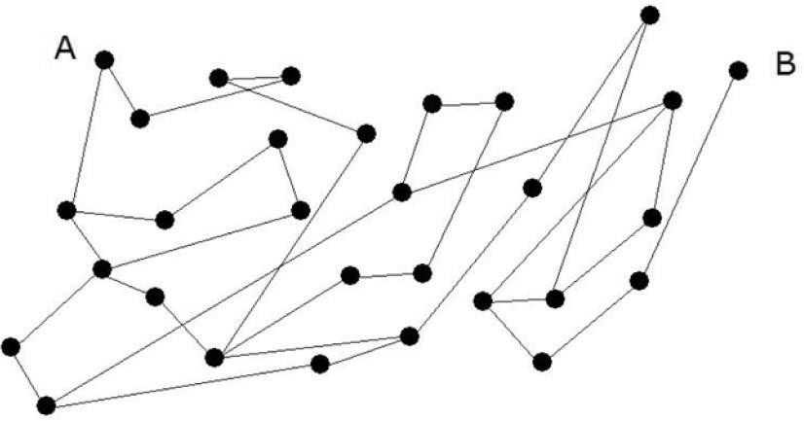

**A.** 10 **B.** 15

**C.** 14 **D.** 13

**E.** 12

1. Which one of the given figures correctly completes the proportion**?**

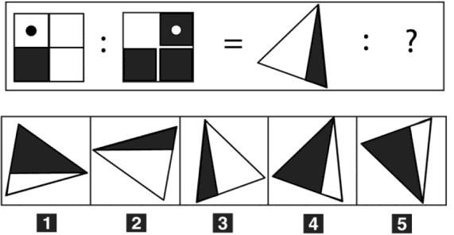

**A.** Figure 1 **B.** Figure 4 **C.** Figure 3

* + 1. Figure 2
    2. Figure 5

1. The price of oil affects food prices. Food prices have risen steeply recently so the price of oil must have increased dramatically.

Which one of the following most closely parallels the reasoning used in the above argument?

1. Being good at maths is necessary for a job in accountancy. Mary is good at maths, so she must be an accountant
2. Lack of exercise causes people to become unfit. A growing number of people today are unfit so exercise must be less common than it was
3. Wearing a crash helmet when riding a bike is essential to avoid a head injury. John never wears a helmet when riding his bike so he will not avoid a head injury
4. That elderly gentleman needs to use a wheelchair so he must not be able to walk. If he did not need to use a wheelchair, he would be able to walk
5. A high level of intelligence is needed to be accepted as a member of MENSA, the club for brainy people. Peter is very clever, so he must be a member of MENSA

**Passage**

**Read the passage and answer each question only on the basis of the information contained (explicitly or implicitly) in the passage, not of what you may know about the topic.**  *The Roman town planning scheme was based on the Greek-Hellenistic Hippodameian system. The streets are mostly straight and arranged in a grid, in parallel with the two main thoroughfares: the cardo maximus to the north and the decumanus maximus from east to west, both in correspondence with the four gates of the city. This layout is not found in Rome, which started as the merging of various settlements in the surrounding hills and valleys. Instead, it is found (and it is often still recognisable) in the cities built by the Romans or Romanised, and corresponds to the plan they used to set up their military camps, many of which later became residential areas. The current names of some modern cities still reveal their origins as a Roman camp, the castrum, not only in Italy, but also abroad (Chester, in England, for example). The intersection between the cardo and the decumanus was usually the location of the Forum, the city's main square: the political, religious and administrative centre where stood the most important public buildings. We will discuss some of these when reviewing the individual monuments; for the moment, it is interesting to observe the shape of Roman residential houses. In particular, we are very familiar with the types of houses found in Pompeii and*

*Herculaneum. As is well-known, the two cities disappeared during the terrible eruption of Vesuvius in 79 AD, the former buried under a pall of ash and lapilli, the latter under an enormous mudslide. This is why, more than many other towns that have undergone endless transformations throughout the centuries, they can give us an accurate idea of what an ancient city looked like, both with regard to general structures and to individual buildings, from the most beautiful and aristocratic to the most humble. The simplest type of Pompeian House, with no or few windows on the street, is structured around a courtyard, the atrium, in the middle of which the rainwater from the opening above (compluvium) is collected in a square-shaped basin (impluvium). All around is a portico on which open the bedrooms (cubicula). At the far end of the atrium, in front of the main entrance, is the tablinum, the most sacred space, where the family meets and receives guests. From here you can go out in the hortus, the garden surrounded by columns (peristyle). Adjacent to the tablinum there is usually the dining room, the triclinium, with three beds next to the three sides of the table. (From: P. Adorno, "L'arte italiana", Casa Editrice G. D'Anna)*

**6.** More than any other town, Pompeii and Herculaneum can give us an idea of what an ancient city looked like because: **(see Passage)**

* 1. the general structures have remained those of the ancient city, while the individual buildings have undergone changes
  2. ashes and mud have preserved the appearance they had at the time of the eruption
  3. despite the changes that have taken place over the centuries, they have preserved both the general structures and individual buildings of the Roman era
  4. the eruption of the Vesuvius did not affect either the general structures or the single buildings
  5. they are the only two Roman towns of which we have remains

# General Culture

**7.** What is the name of the literary movement born in France in the second half of the 19th century under the influence of positivism, which dictates that the experimental method should be applied to the writer's work?

1. Classicism
2. Abstractism
3. Naturalism
4. Existentialism
5. Decadentism

1. The government of the Italian Social Republic was based in:

* 1. Milan
  2. Salò
  3. Turin
  4. Salerno
  5. Rome

1. Which of these Life Senators was nominated by the President of the Republic Sergio Mattarella?

* 1. Mario Monti
  2. Carlo Rubbia
  3. Elena Cattaneo
  4. Liliana Segre
  5. Renzo Piano

1. Which one of these film directors CANNOT be considered an exponent of neorealism?

* 1. Roberto Rossellini
  2. Franco Zeffirelli
  3. Vittorio De Sica
  4. Pietro Germi
  5. Luchino Visconti

1. The United Nations’ General Assembly:

* 1. meets once a month in ordinary session
  2. is where the Prime Ministers of Member States meet
  3. is elected democratically
  4. substituted the Security Council from 1996
  5. is a representative organ of member States

1. What does the term “palimpsest” denote?

* 1. A notepad, equipped with pencil holder
  2. In a theatre show, a short musical intermezzo subtending manifest, or hidden, commercial aims

* 1. A texture of sounds played together, by voices and instruments, each with a specific melodic line
  2. An ancient manuscript on parchment, from which an older text has been scraped off and can be re-used
  3. A rather wide arch, typical of late ancient architecture

1. Who supports the Theory of Evolution in his famous book “The Origin of Species”?

* 1. Dmitrij Ivanovič Mendeleev
  2. Isaac Newton
  3. Charles Robert Darwin
  4. Johann Gregor Mendel
  5. Epicurus

1. Cast iron is:

* 1. an alloy of iron and carbon
  2. an alloy of iron and tin
  3. an iron alloy containing lead
  4. tempered soft iron
  5. an iron alloy containing copper

# History of Art

1. Determine the correct chronological order of the following artistic movements.

* 1. Neoclassicism, Impressionism, Pop Art, Expressionism
  2. Impressionism, Pop Art, Expressionism, Neoclassicism,
  3. Impressionism, Expressionism, Neoclassicism, Pop Art
  4. Pop Art, Expressionism, Impressionism, Neoclassicism, **E.** Neoclassicism, Impressionism, Expressionism, Pop Art

1. The "Aventine secession" took place as a result of which event?

* 1. The assassination of Matteotti
  2. The "very fascist laws"
  3. The March on Rome
  4. The imprisonment of Antonio Gramsci
  5. The Biennio Rosso

1. What is the name of the work in the figure and who is the artist?

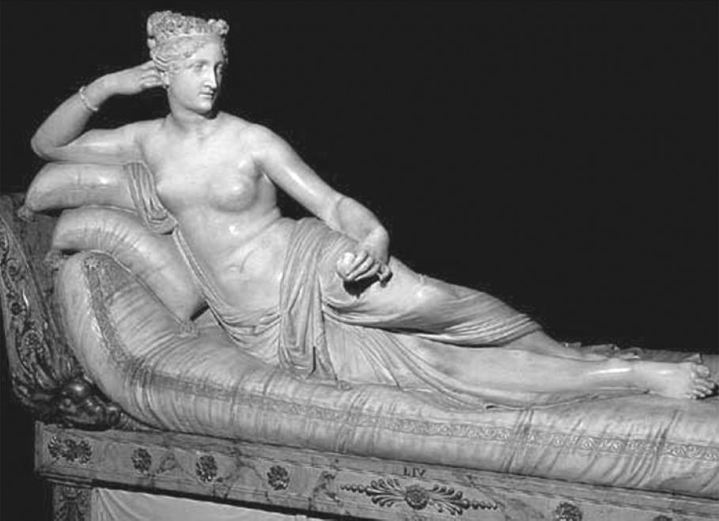

* + - * 1. *“Truth Unveiled by Time”* by Gian Lorenzo Bernini

* + - * 1. *“Hebe”* by Antonio Canova

* + - * 1. *“Paolina Borghese”* by Antonio Canova

* + - * 1. Venus de' Medici

* + - * 1. *“Naiade”* by Antonio Canova

1. Which of the following events gave Hitler the pretext to initiate a repressive campaign against the communists in 1933?

* + 1. The Nazi book burning in Berlin
    2. The Night of the Long Knives
    3. The Reichstag fire
    4. The failed annexation of Austria into Nazi Germany **E.** The rise to power of Stalin in Russia

1. The ‘Battle for Grain’ was:

* + 1. the climax of the revolt of the Cossacks against the Russian Army
    2. the war between Venice and the Ottoman Empire for the control of the Mediterranean Sea
    3. a popular revolt of German peasants led by Thomas Müntzer
    4. a fascist campaign aimed at making Italy less dependant on imports
    5. a popular insurrection in Paris that led to the storming of the Bastille

1. Indicate the artist and the name of the work in the figure.

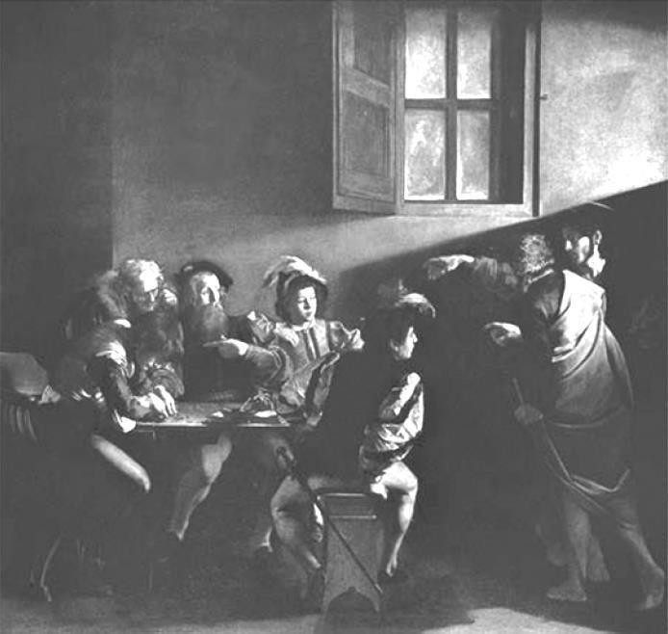

* + 1. *“The Cardsharps”* – Caravaggio
    2. *“The Calling of St Matthew”* – Caravaggio
    3. *“Girl Interrupted at Her Music”* – Jan Vermeer
    4. *“The Triumph of Bacchus (The Drinkers)”* – Diego Velázquez
    5. *“Supper at Emmaus”* – Caravaggio

1. Which one of the following is NOT commonly found in classical Greek architecture?

* 1. Vault
  2. Column
  3. Tympanum
  4. Moulding
  5. Capital

1. The sculpture below is by**:**

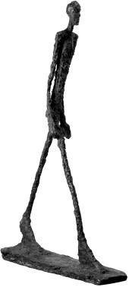

* + - 1. Arturo Martini
      2. Marino Marini
      3. Alberto Giacometti
      4. Francesco Messina
      5. Giacomo Manzù

1. Which one of the following terms does NOT correspond to a type of vault?

* 1. Rib vault
  2. Truss vault
  3. Pavilion vault
  4. Schifo vault
  5. Barrel vault

1. Of which architectural style is the image in the figure representative**?**

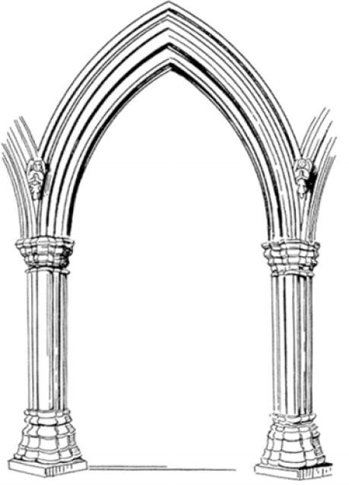

* + - * 1. Baroque
        2. Romanesque
        3. Neoclassical
        4. Byzantine
        5. Gothic

1. On 31st March 2016, an internationally renowned figure in architecture and design died who, in Italy, created a number of works such as the *“MAXXI – National Museum of the Arts of the 21st Century”* in Rome and the so-called *“Crooked”* skyscraper of Milan. Who was it?

* + - 1. Frank O. Gehry
      2. Massimiliano Fuksas
      3. Zaha Hadid
      4. Denise Scott Brown
      5. Kazuyo Sejima

1. Who designed this important museum?

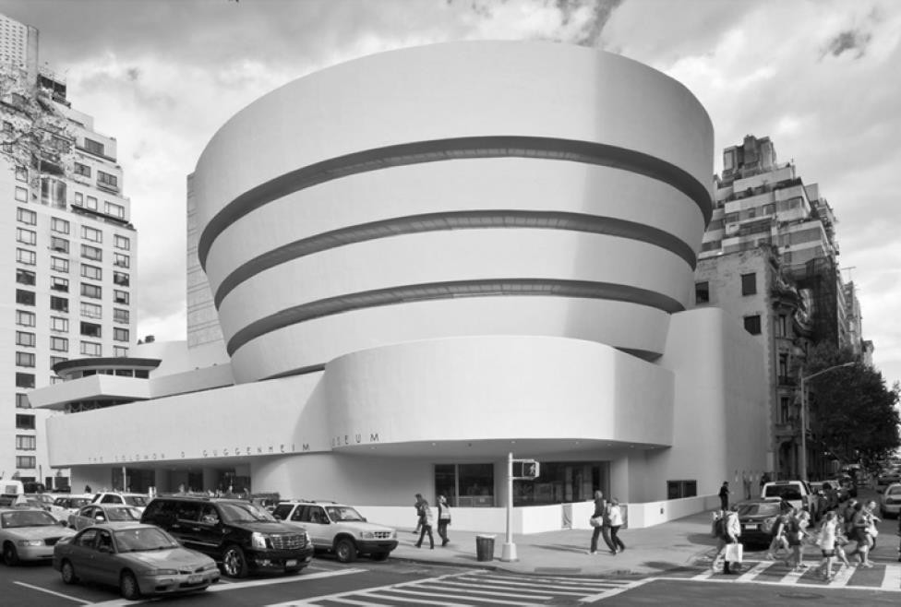

* + - 1. Frank Lloyd Wright
      2. Frank O. Gehry
      3. Ludwig Mies van der Rohe
      4. Philip Johnson
      5. Alvar Aalto

# Design Test & Representation

1. Which of the following statements is NOT correct?

* 1. An A0 sheet is equal to four A3 sheets
  2. An A1 sheet is equal to four A3 sheets
  3. An A2 sheet is equal to four A4 sheets
  4. An A1 sheet is equal to eight A4 sheets
  5. An A0 sheet is equal to four A2 sheets

1. Given the drawing in orthogonal projection, identify the corresponding axonometric projection.

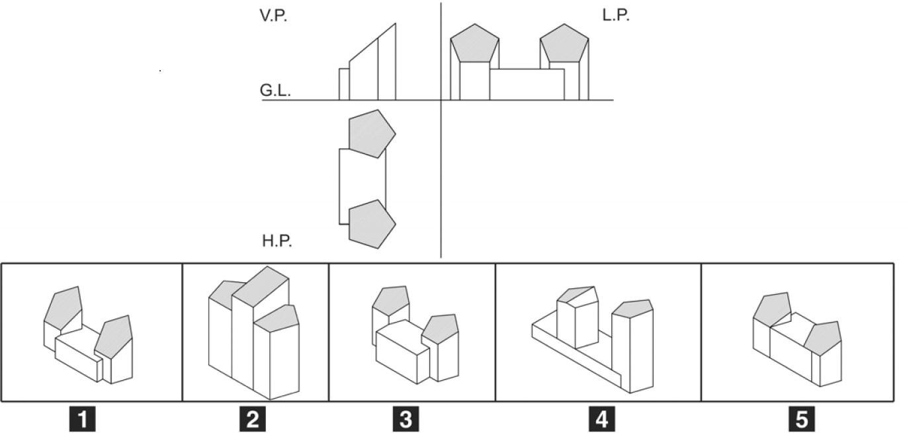

* 1. 2 **B.** 4

**C.** 1 **D.**

3

**E.** 5

1. Match the correct 3D model with each plan**.**

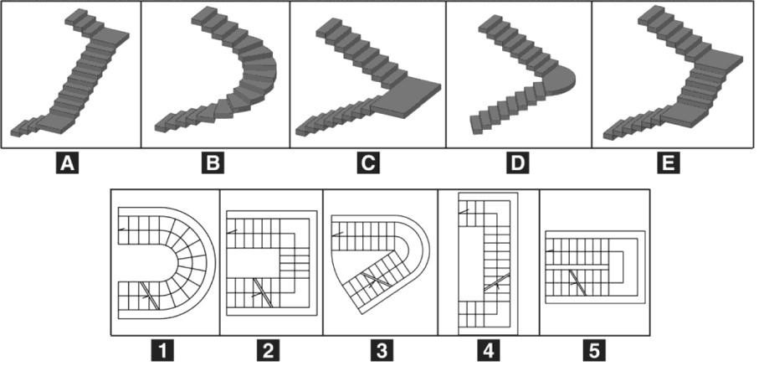

* 1. 1B, 2E, 3D, 4A, 5C **B.** 1D, 2A, 3E, 4B, 5C **C.** 1C, 2B, 3A, 4D, 5E **D.** 1E, 2A, 3B, 4D, 5C **E.** 1A, 2C, 3D, 4E, 5B

1. The metric survey image below corresponds to a specific model. Which one?

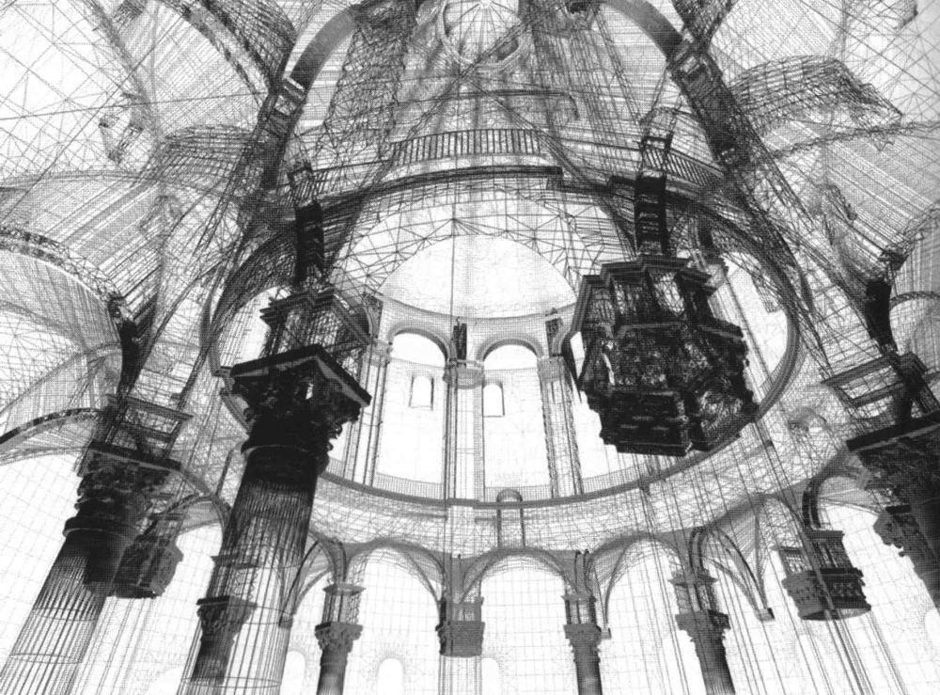

* + 1. A point cloud digital model
    2. An axonometric digital model
    3. A plastic model
    4. A wooden model
    5. A perspective wireframe digital model

1. Referring to the plane that divides up the solids represented, which is the correct section?

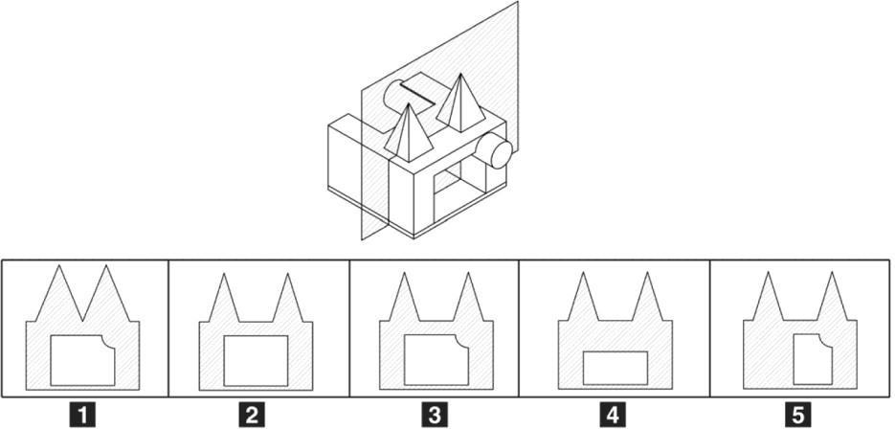

* 1. 5 **B.** 3 **C.** 2 **D.** 1

**E.** 4

1. Find the right match of plan and axonometric view.

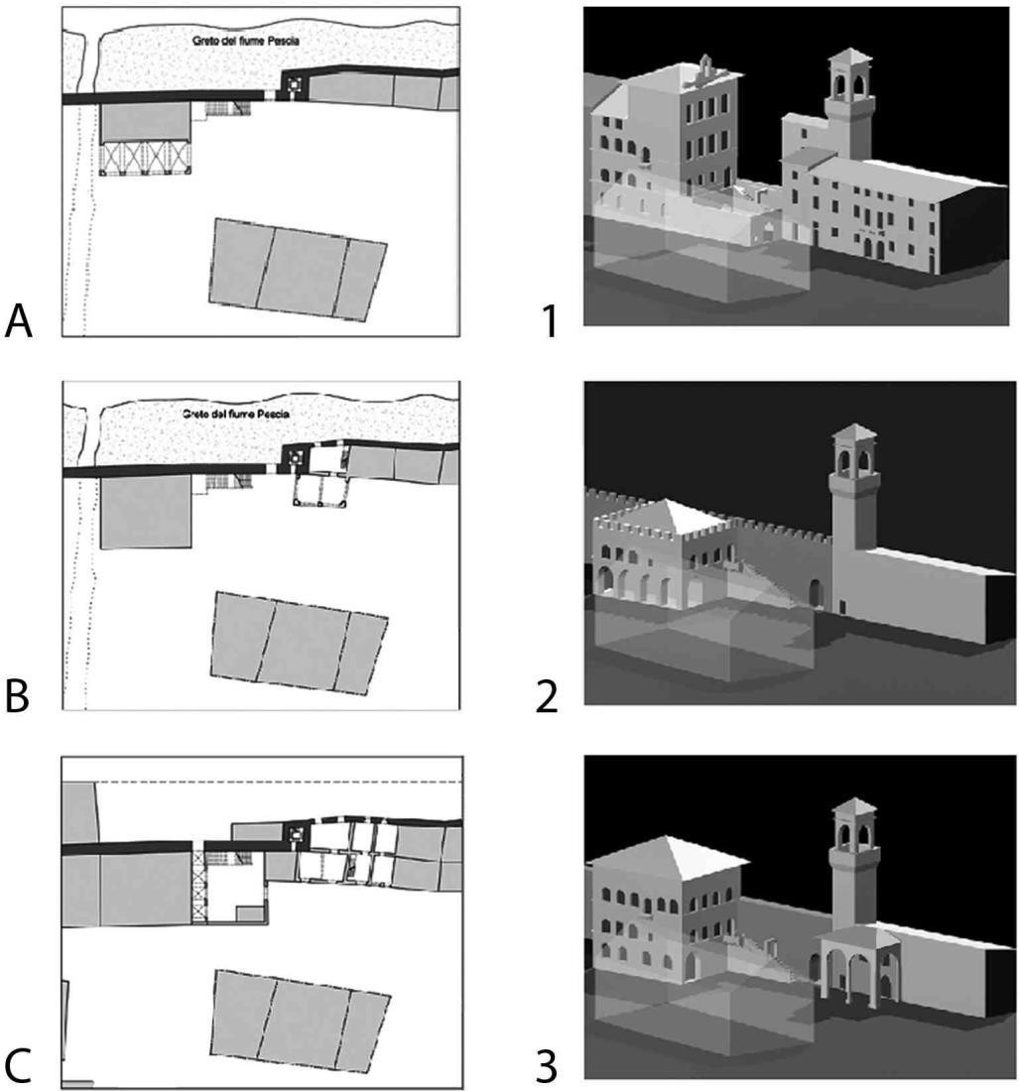

**A.** A-2, B-3, C-1 **B.** A-2, B-1, C-3

* + - 1. A-3, B-2, C-1
      2. A-1, B-2, C-3
      3. No matching possibile

**Physics and Mathematics**

1. From a standstill an object moves with constant acceleration and covers 5 m in the first second. What distance does it travel in the next second?
   1. 5 m
   2. 40 m **C.** 10 m
   3. 15 m
   4. 30 m

1. Three small conducting spheres A, B and C have the same radius. Sphere A has a charge 2q, sphere B has a charge q, while C is neutral. Sphere A is first placed in contact with B and the with C; after these two contacts what is the charge of A:

* 1. 3q
  2. q
  3. 5q/4
  4. 2q
  5. 3q/4

1. At 3:30 p.m. the odometer of a car marks 22,715. If at 5:00 p.m. the odometer marks 22,865, what was the average speed of the car?

* 1. 150 km/h
  2. 100 km/h
  3. 50 km/h
  4. 10 km/h
  5. 200 km/h

1. A metal bar 1 metre long is suspended by its centre. At 10 cm from the left end hangs a 10 kg weight, while at the other end hangs a 12 kg weight. What must you do to balance the bar and keep it horizontal?

1. Add to the weight hung on the left end another weight of 5 kg
2. Add to the weight hung on the right end another weight of 5 kg
3. Add to the weight hung on the left end another weight of 4 kg
4. Nothing, the bar is already balanced
5. Add to the weight hung on the right end another weight of 4 kg

**37.** A mass, hung on a spring, oscillates along a vertical line about a stable equilibrium position. Below are four statements about the motion of the mass.

1. The velocity is greatest at the equilibrium position.
2. The acceleration is greatest at the equilibrium position.
3. The acceleration is directed towards the equilibrium position.
4. The kinetic energy is greatest at maximum displacement.

Which statement(s) is/are correct?

* + 1. 4 only
    2. 1, 3 and 4 only
    3. 1 and 3 only
    4. 2 and 4 only
    5. none of them

* 1. The solutions to the inequality (2 – x)(x + 1)x < 0 are:

* + 1. –1 < x < 0 or x > 2
    2. x < –1 or 0 < x < 2
    3. –1 < x < 0
    4. x > 2
    5. 0 < x < 1 or x > 2

* 1. A box contains 4 red balls, 5 orange balls, 5 purple balls and 6 yellow balls. What is the probability that, pulling out two balls one after the other, and putting them back, only one purple ball will be pulled out?

* + 1. 5/8
    2. 5/16
    3. 16/9
    4. 3/8
    5. 3/16

* 1. What does the area of the triangle ABC in the figure measure?

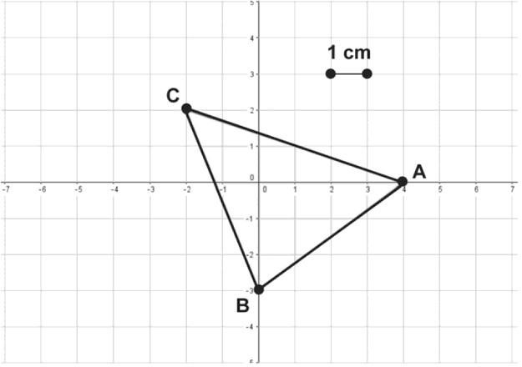

* + 1. 15 cm2 **B.** 13 cm2 **C.** 12 cm2
  1. 14 cm2
  2. Insufficient data to determine the area of the triangle